44.16: The available energy 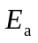 must be 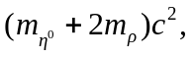 so Eq. (44.10) becomes
